NEXTCLOUD PI

Install Nextcloudpi onto SD card
- Install Gparted (for windows, you can use Windows Computer Management or Partition Magic)
  - sudo apt-get install gparted
- Format SD card to FAT32 (SD bigger than 8Gb)
- Install Balena Etcher (available for windows):
  - https://www.balena.io/etcher/ → Download → Unzip → Install
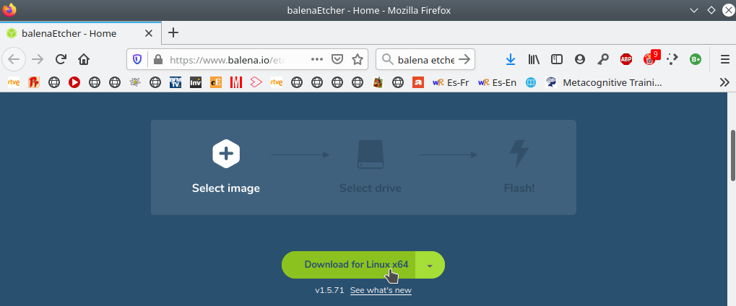

- Download NextcloudPi
  - https://ownyourbits.com/nextcloudpi/ → RaspberryPi : More instructions → Ownyourbitswebsite
  - Download : NextCloudPi_RPi_mm-dd-yy.tar.bz2
  - Un zip NextCloudPi_RPi_mm-dd-yy.tar.bz2
  - You will find the file NextCloudPi_RPi_mm-dd-yy.img
  - mm-dd-yy : Month, day and year of distribution
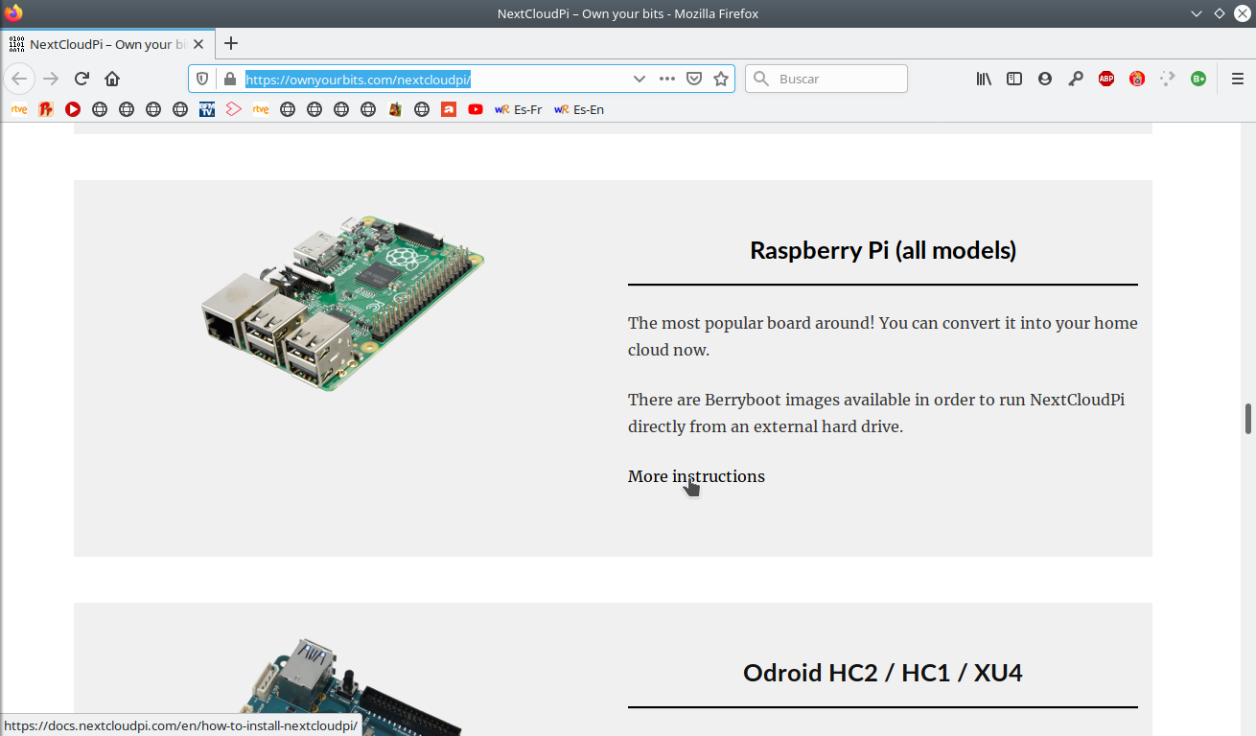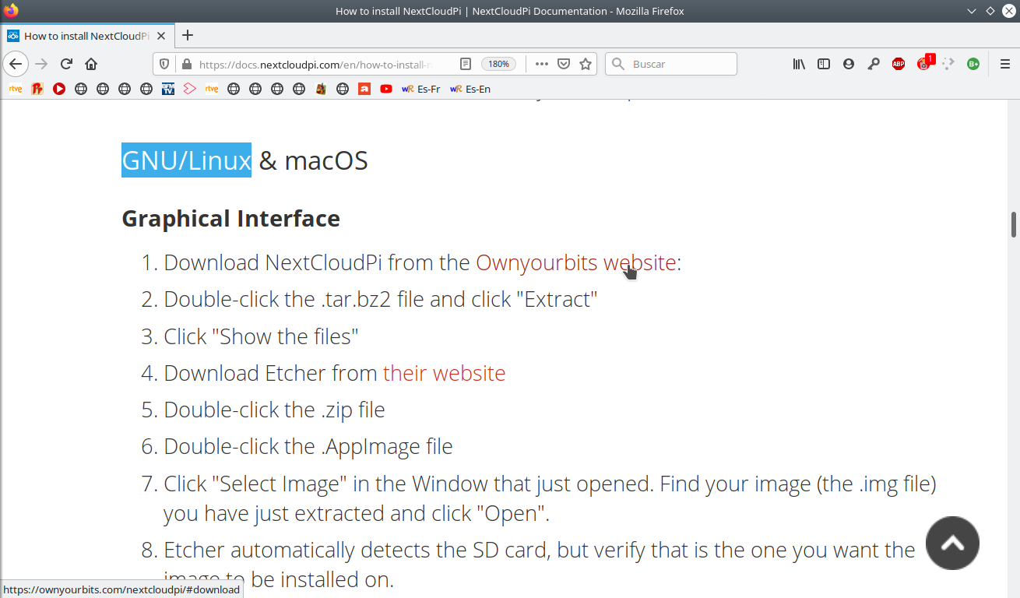
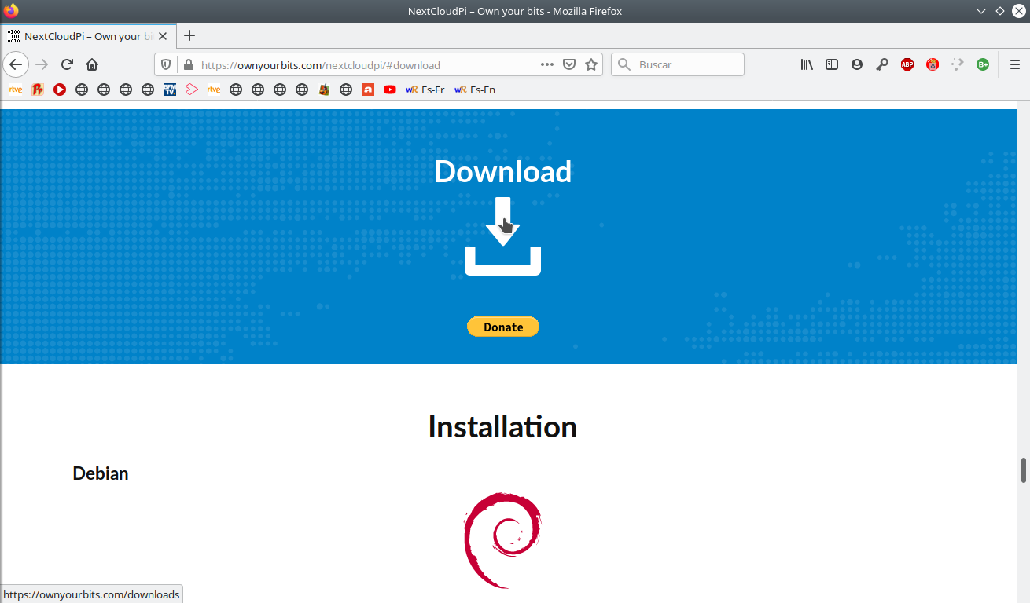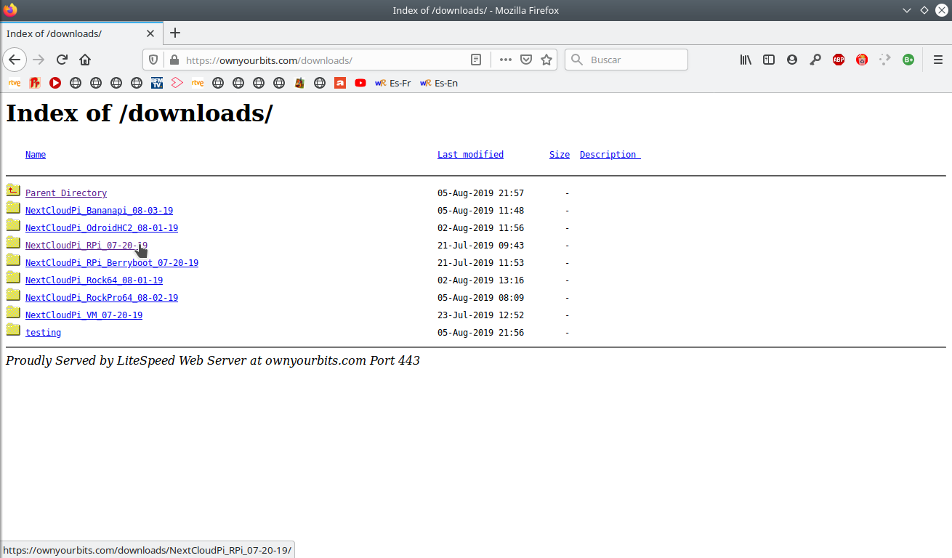
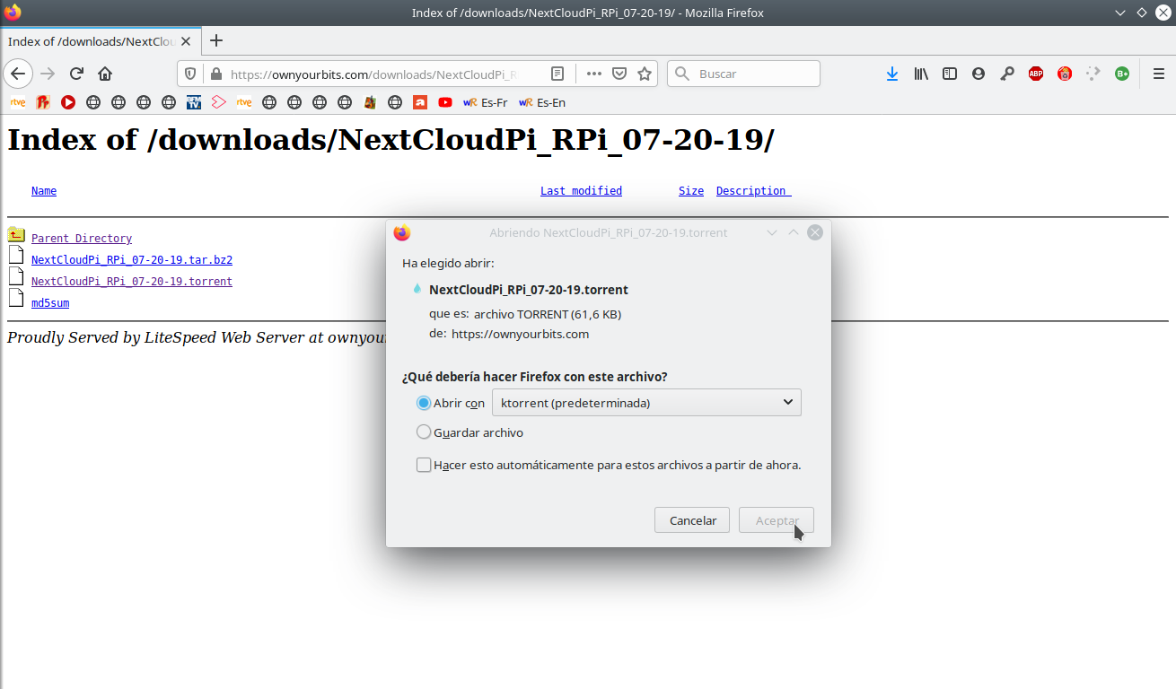

- Install Nextcloudpi onto SD card
  - Open Balena Etcher → Select image → NextCloudPi_Rpi_mm-dd-yy.img
  - Select your SD card → Change → Flash
  - Then, open Gparted to resize the partition installed and to use all SD card capacity (Not make SWAP partition!)
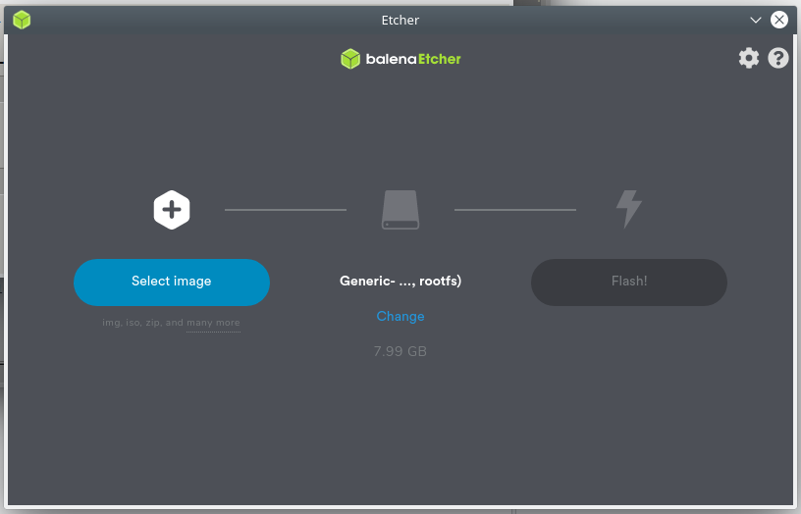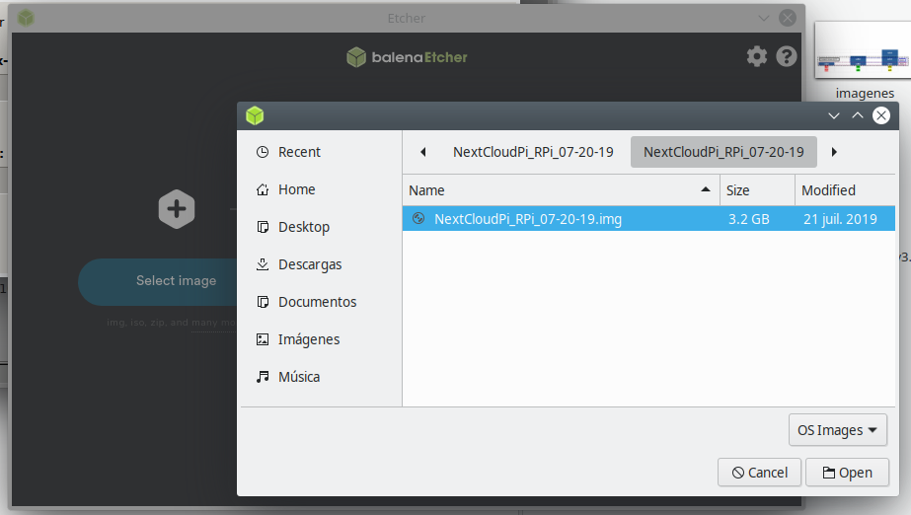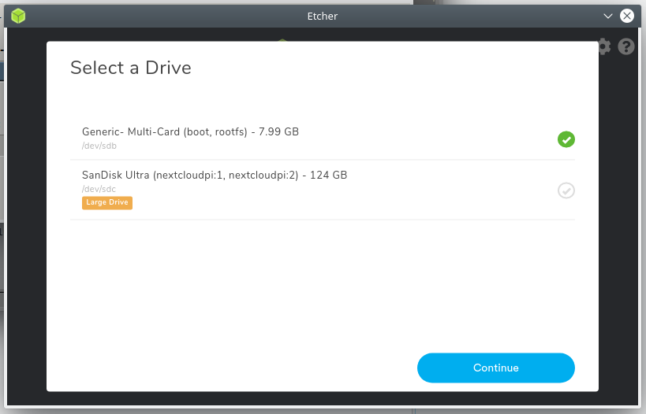

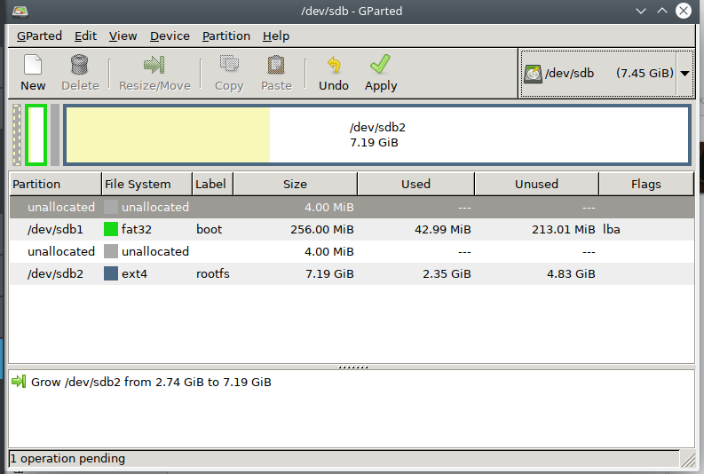

Acces to Nextcloudpi from PC
- With the SD card in the PC
  - Now, your SD card has 2 partitions : BOOT and ROOTFS
  - Go to BOOT partition of your SD card
    - Create a file called ssh (without extension)
    - Create a file called wpa_supplicant.conf
      - Edit wpa_supplicant.conf with the BlocNote
      - Paste the code below:
      - country=fr
update_config=1
ctrl_interface=/var/run/wpa_supplicant
network={
scan_ssid=1
ssid="Wifi name or ssid"
psk="Wifi Password"
}
    - Wifi name or ssid
    - Wifi Password
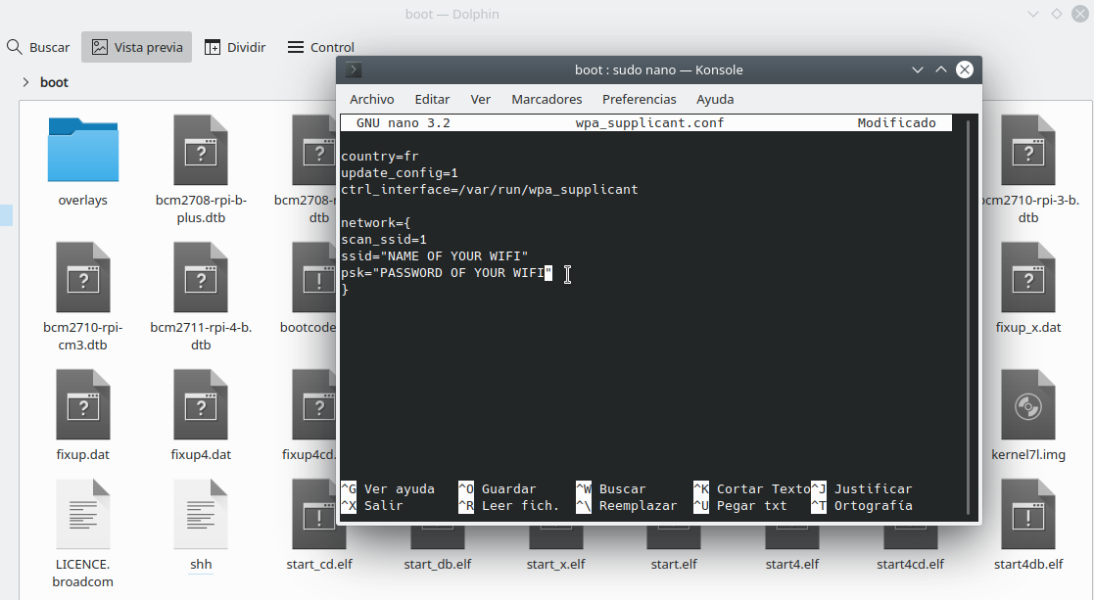

- Static adresse for the Raspberry Pi
  - Install PuTTY (available for windows)
  - To know the router IP address in LINUX
    - ip r
    - And the number after “default via” is the IP address of your router. For exemple 192.168.1.35
  - To know the router IP address in any operating system
    - Install the application Fing in you smartphone
    - Then, connect your smartphone by wifi and looking for the devices connected
    - You will recognize your IP address of your router (in my case 192.168.1.35 see the orange square)
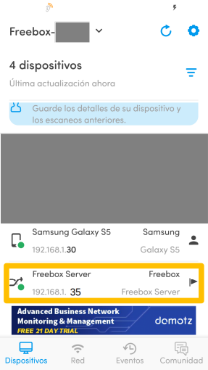
  - Go to ROOTFS partition of your SD card and open the file /Etc/dhcpcd.conf
    - Edit dhcpcd.conf with the BlocNote
    - Paste the code below at the end of document:
    - interface eth0
static ip_address=192.168.1.200/24
static routers=192.168.1.35
static domain_name_servers=192.168.1.35
interface wlan0
static ip_address=192.168.1.200/24
static routers=192.168.1.35
static domain_name_servers=192.168.1.35
  - IP address of RaspberryPI, for example: 192.168.1.200 (in order to prevent problems, the last number “200”, should be close to 200)
    - Each device has an IP addressee for the router. So, you can verify with the application Fing, if the IP address is free.
- Extract the SD card from the PC, put it in the raspberry Pi
- Open PuTTY
  - In Host Name, you can write the raspberry IP adresse of RaspberryPI → Open
  - The first time, you have to accept the security alert
  - The first time can take same minutes
  - For to copy/paste you can push the mouse scroll wheel
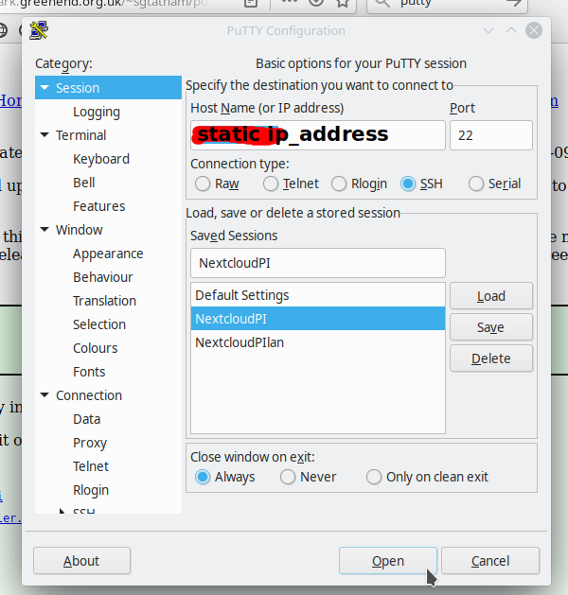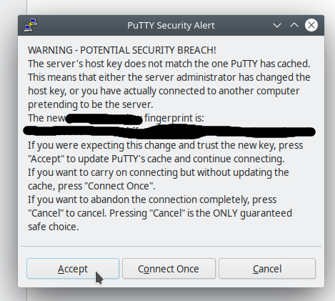
- Raspberry pi connection from PC
  - By Default, the id and the password are ;
    - ID : pi
    - PASSWORD: raspberry
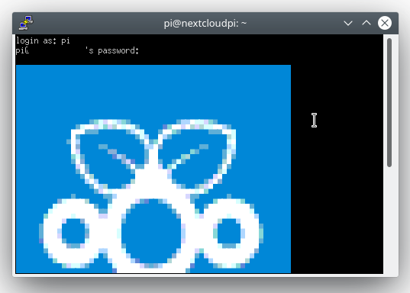
- The first connection, you should to change the password
  - sudo passwd root
    - PASSWORD-Pi
  - sudo passwd
    - PASSWORD-Pi
  - Change time zone
    - sudo raspi-config → 4 Localisation Options → Change Time Zone
  - Upload the systeme
    - sudo ncp-update
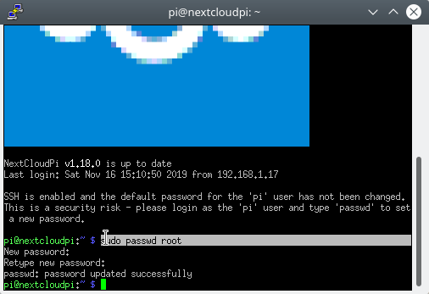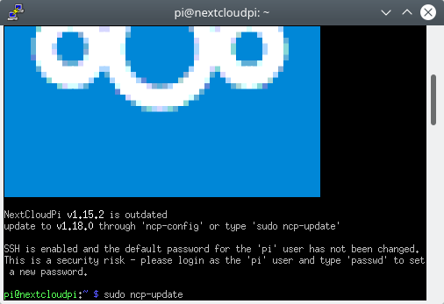
  - Turn off the Raspberry Pi
    - sudo poweroff

Configuration of RAID
- For information about the RAIDs https://en.wikipedia.org/wiki/RAID
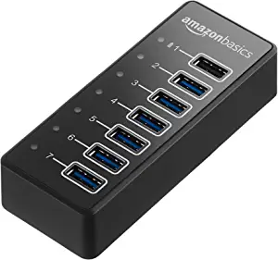
- Connect the HDDs to the HUB and the HUB to the Raspberry Pi
  - About the HUB, my recommendation is the HUB USB 3.0 from AmazonBasics :
https://www.amazon.com/AmazonBasics-USB-C-3-1-adaptador-alimentaci%C3%B3n/dp/B076YN9FW4?ref_=ast_sto_dp

  - Install the programs for the raid
    - sudo apt-get install lvm2 mdadm ntfs-3g
    - sudo reboot
- Assuming that the HDDs have not the same capacity and in order to optimize the HDDs capacity, the HDDs will be parted as below with Gparted (or another in windows)
  - The format is not important, but my recommendation is EXT4
  - For example:
    - Assuming that I have 3 HDDs, and the smallest HDD have 1Tb (sda). I should to make 1 partition of 1Tb to 2 others HDDs.
    - The second smallest HDD of 2Tb (sdb) would have a 1st partition (sdb1) of 1Tb and a 2nd partition (sdb2) of 2Tb. So, we should make a 2nd partition (sdc2) of 2Tb too in the HDD of 5Tb.
    - The 3rd partition (sdc3) of 2Tb of HDD of 5Tb couldn’t be used
    - The RAID 1 will be composed by the partitions of 1Tb (sda1, sdb1 and sdc1)
    - The RAID 2 will be composed by the partitions of 1Tb (sdb2 and sdc2)
    - Finally, the RAID 1 and the RAID 2 will be in a same volume. This volume will be used “as a simple HDD” but if a HDD is broken, we will not lost the information
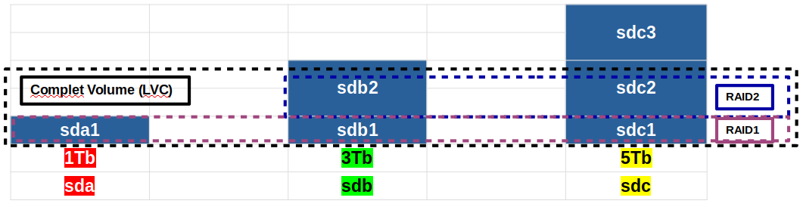
- Creating the RAIDs following the previous structure.
For this example, I have used the smaller HDDs (1Gb, 3Gb and 5Gb instead of 1Tb, 3Tb and 5Tb) because it’s only for showing but it’s exactly the same steps
  - To see the partitions of your HDDs
    - sudo fdisk -l
    - We can see the HDDs (1Gb, 3Gb and 5Gb) and theirs partitions in the square red, green and yellow,
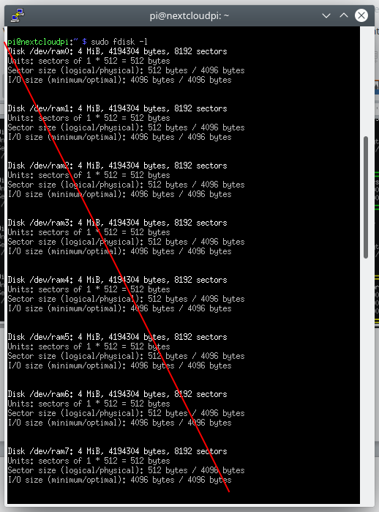
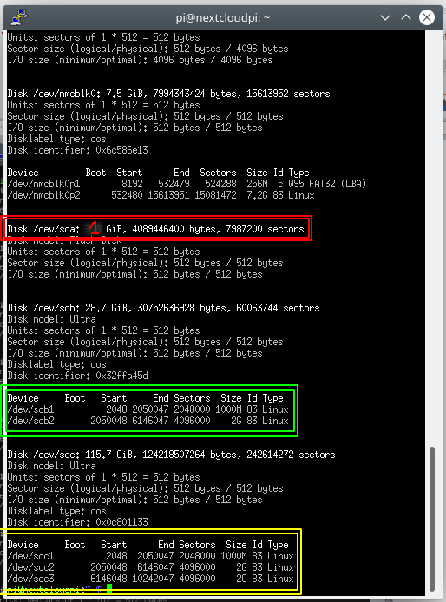
  - The RAID 2 will be a Mirror RAID (or RAID 1), the partitions sdb2 and sdc2 are identical
  - sudo mdadm -Cv /dev/md2 -l1 -n2 /dev/sdb2 /dev/sdc2
    - md2: Identification number of Raid (you can use an other number)
    - -l1: Raid 1 or Mirror
    - -n2: RAID composed by 2 HDD
    - /dev/sdb2 /dev/sdc2: Partitions sdb2, sdc2
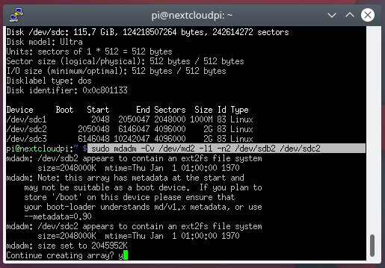
    - Answer “y” to the question “Continue creating array?”
    - The synchronization between HDDs, can take many time. If you lost the connection through putty, you can just reload putty and you can see the synchronization progression with the follow code:
      - sudo cat /proc/mdstat

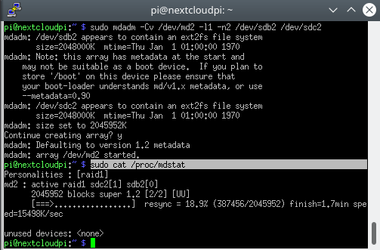

  - Similar to RAID 2, the RAID 5 with the partitions sda1, sdb1 and sdc1 (see, en.wikipedia.org/wiki/RAID)
  - sudo mdadm -Cv /dev/md1 -l5 -n3 /dev/sda1 /dev/sdb1 /dev/sdc1
    - md1: Identification number of Raid (you can use an other number)
    - -l5 : Raid 5
    - -n3 : RAID composed by 3 HDDs
    - /dev/sda1 /dev/sdb1 /dev/sdc1 : Partitions sda, sdb1, sdc1.
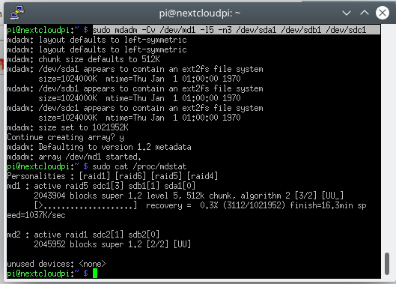

Create a unique volume with all RAIDs (LVM)
- WHEN THE SYNCHRONIZATION FINISHES, Create the Physical Volume (PV)
  - sudo pvcreate /dev/md1 /dev/md2
    - md1: Identification number of Raid (you can use an other number)
  - sudo pvdisplay
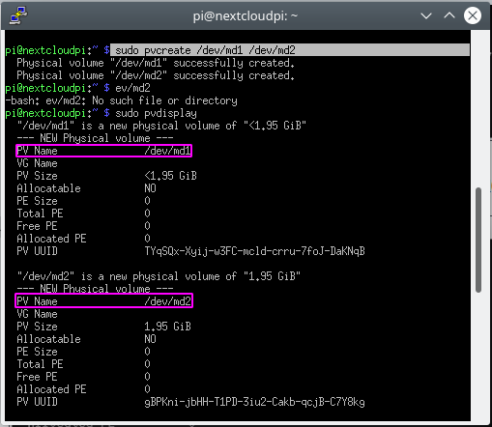
- Create the Volume Group (VG) in LVGraid
  - sudo vgcreate LVGraid /dev/md1 /dev/md2
    - mdx: Identification number of Raid (you can use an other number)
    - LVGraid: Name of Volume Groupe (VG)
    - VG Side: Memory available (3,89Gb in our exemple)
  - sudo vgdisplay

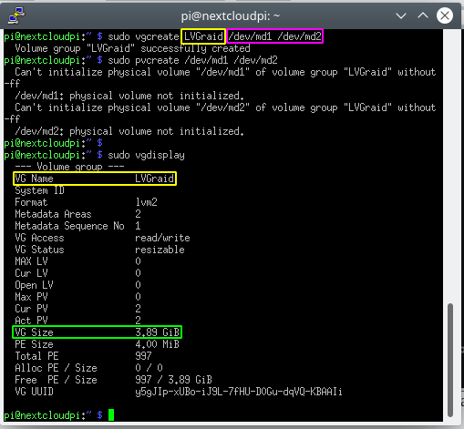

- Create the logical volumes (LV) in LVMraid
  - sudo lvcreate -l 100%FREE -n LVMraid LVGraid
    - 100%FREE: All memory available (3,89Gb in our exemple)
    - LVGraid: Name of Volume Groupe (VG)
    - LVMraid: Name of Logical Volume (LV)
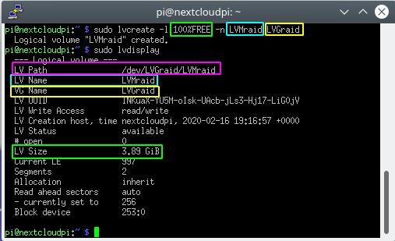
    - /dev/LVGraid/LVMraid: Address where the Logical Volume (LV)
  - sudo lvdisplay

- Format Logical Volume (LV) to BTRFS
    - sudo mkfs -t btrfs -f /dev/LVGraid/LVMraid
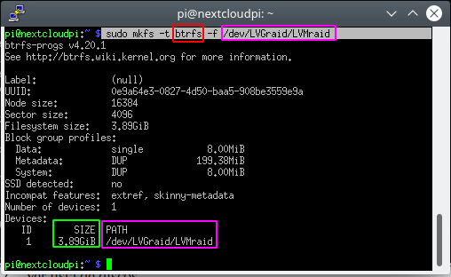
- See the Logical Volume (LV)
  - sudo fdisk -l
    - /dev/mapper/LVGraid-LVMraid: Address where the Logical Volume (LV) is mounted
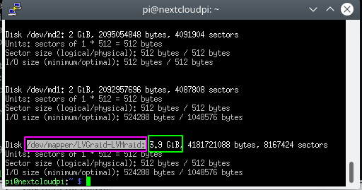
- Create the folder where your data will be stored
  - cd /
  - sudo mkdir /RAID
  - cd /RAID
  - sudo mount /dev/mapper/LVGraid-LVMraid /RAID
    - /dev/mapper/LVGraid-LVMraid: Address where the Logical Volume (LV) is mounted
    - /RAID: Address where Logical Volume (LV) will be mounted
- sudo mkdir ncp-database
- Create others useful folders
  - sudo mkdir /USB

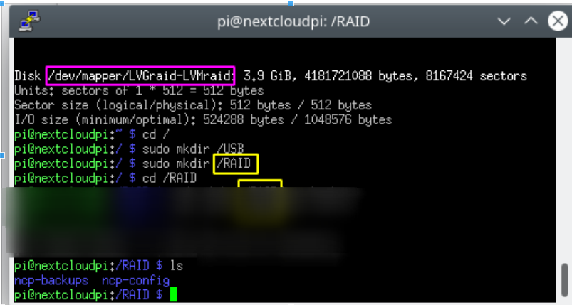
- Mount Logical Volume (LV) in the /RAID folder
  - sudo nano /etc/fstab
  - Write : /dev/mapper/LVGraid-LVMraid /RAID btrfs rw,relatime,space_cache,subvolid=5,subvol=/ 0 0
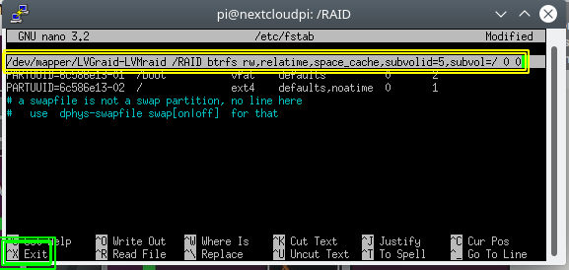
  - Exit phusing:
    - Crtl + X
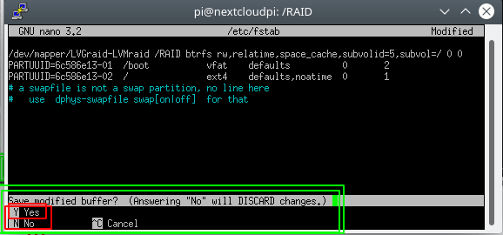
  - Save the changes (pushing Y) in the address folder: /etc/fstab (pushing Enter)
    - Y
    - Enter
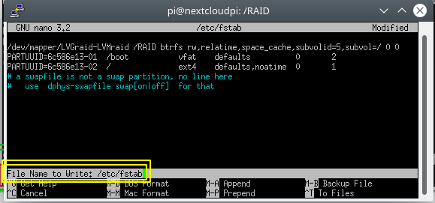

Install NextcloudPi
- Go the IP address of RaspberryPi previously fixed (see page 6) with firefox (or another)
  - https://192.168.1.200/
  - Push “avanced”
  - Push “accept the risk”
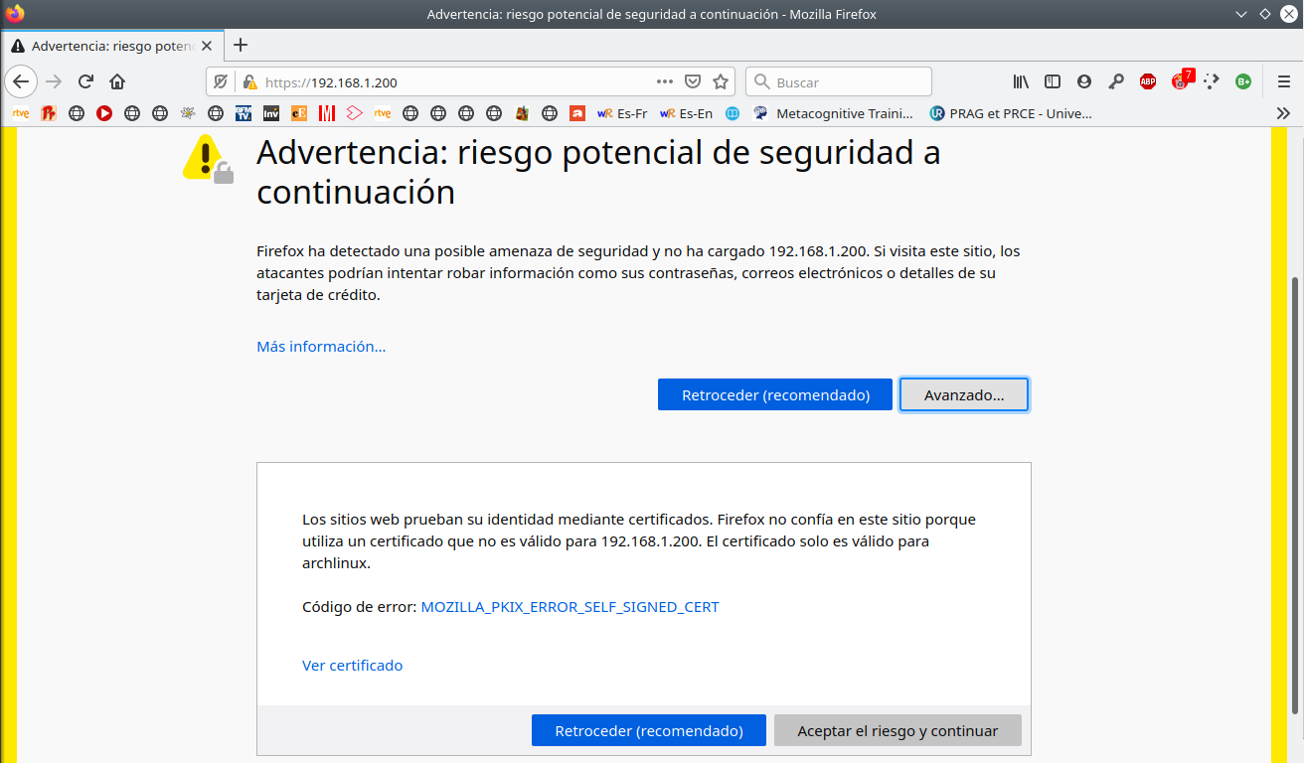

- Print all information
- Copy the Id and the Password of NextcloudPi count into a bloc text:
  - Address: https://nextcloudpi.local:4443
  - Id: ncp
  - Password: Ye3FNazH7fBMAXA+7fuOlr9c42zCTHqDhZZxwEesWQc
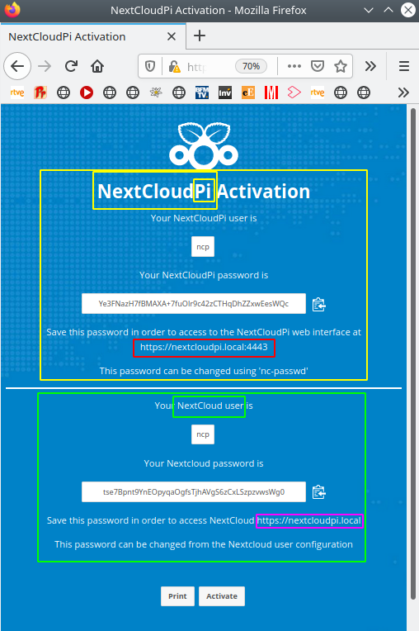
- Copy the Id and the Password of Nextcloud count into a bloc text:
  - Address: https://nextcloudpi.local
  - Id: ncp
  - Password: tse7Bpnt9YnEOpyqaOgfsTjhAVgS6zCxLSzpzvwsWg0

Configuracion Nextcloud
- Active the NextcloudPi count and the Nextcloud count
  - Push “Active”
- Open Nextcloud
  - Address: https://nextcloudpi.local
- The first time that you will open the Nextcloud count, you need to accept the risk again:
  - Push “avanced”
  - Push “accept the risk”
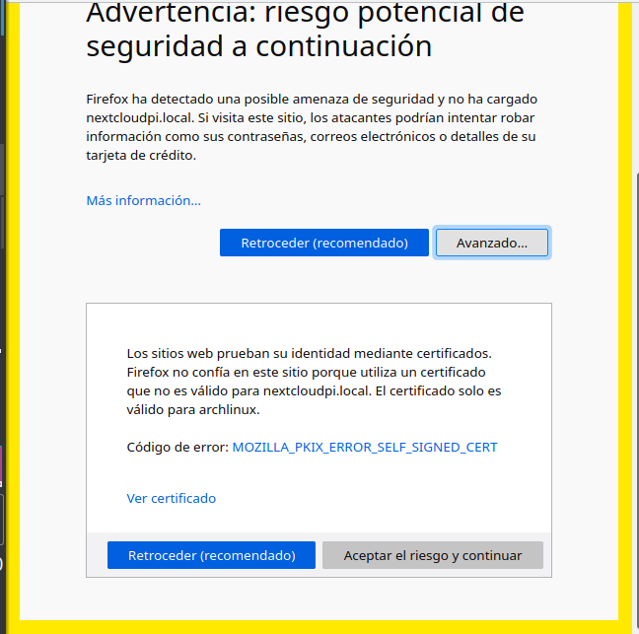
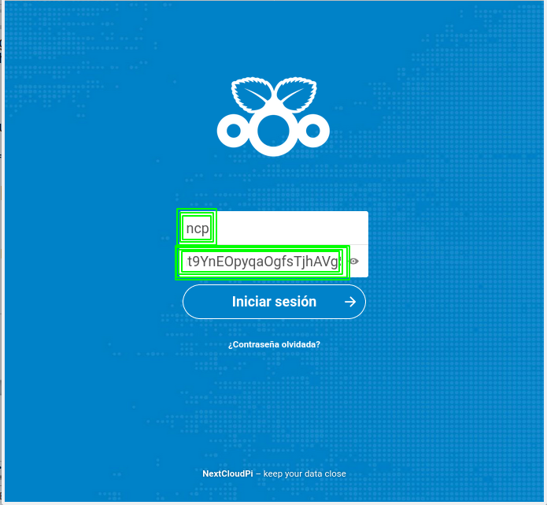
- The Id and the password come from the previous windows below
  - Id: ncp
  - Password: tse7Bpnt9YnEOpyqaOgfsTjhAVgS6zCxLSzpzvwsWg0
- After some minutes (only the first time), you can close the welcome windows
- Create a new folder “ncp-backup”, where all backups of NextcloudPi will be stored
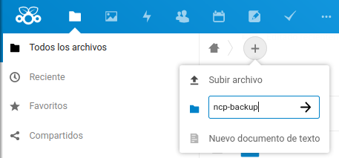
- Change the password
  - Go to “Configuration” → “Personal” → “Security”
    - “Old password”: tse7Bpnt9YnEOpyqaOgfsTjhAVgS6zCxLSzpzvwsWg0
    - “Password”: 1+1+2+3+5+8+13+21+34
    - Push “save”

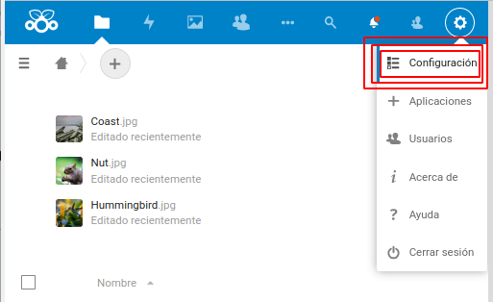
- Mail configuration
  - Firstly, it’s necessary to allow “less secure apps” to sing in to your gmail:
    - https://support.google.com/accounts/answer/6010255?hl=en
    - https://myaccount.google.com/intro/security
  - Go to “Configuration” → “Administration” → “Basic setting” → “Email server”
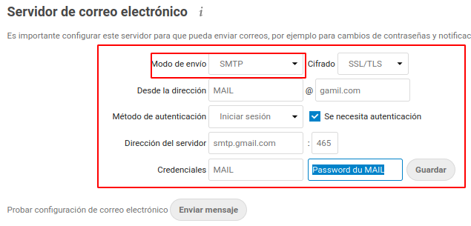
    - “send mode”: SMTP
    - “Encryption”: SSL/TLS
    - “From adress”: MAIL@gmail.com
    - “Authentication method”: Login
    - “Authentication required”: Activated
    - “Server adress”: smtp.gmail.com
    - “port”: 587 (o 465)
    - “Credentials”: MAIL (without @gmail.com)
    - “Password”: Password of your eMail

- Active USB external memory
  - Go to “Applications” → “Administration” → “External storage support” → “Active”
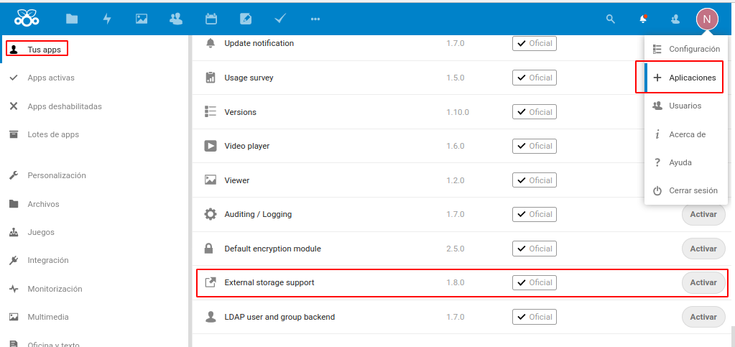
  - Write the Nextcloud Password
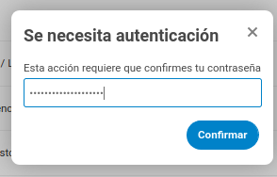
  - Go to “Configuration” → “Your apps” → “External storage support” → “External storage”
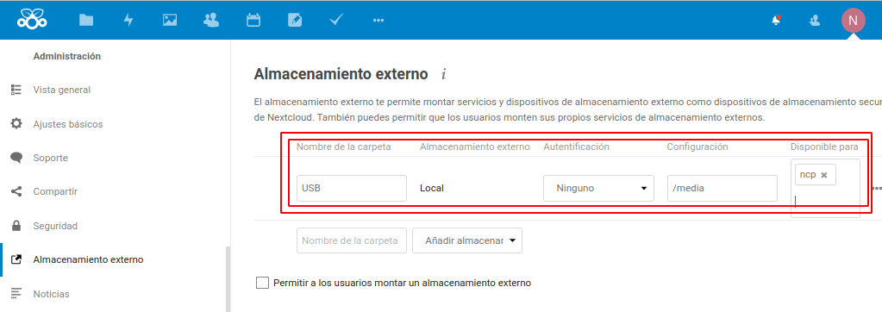

NextcloudPi Configuration - “CONFIG MENU”
- The first time that you will open the NextcloudPi count, you need to accept the risk again:
  - Address: https://nextcloudpi.local:4443
  - Push “avanced”
  - Push “accept the risk”
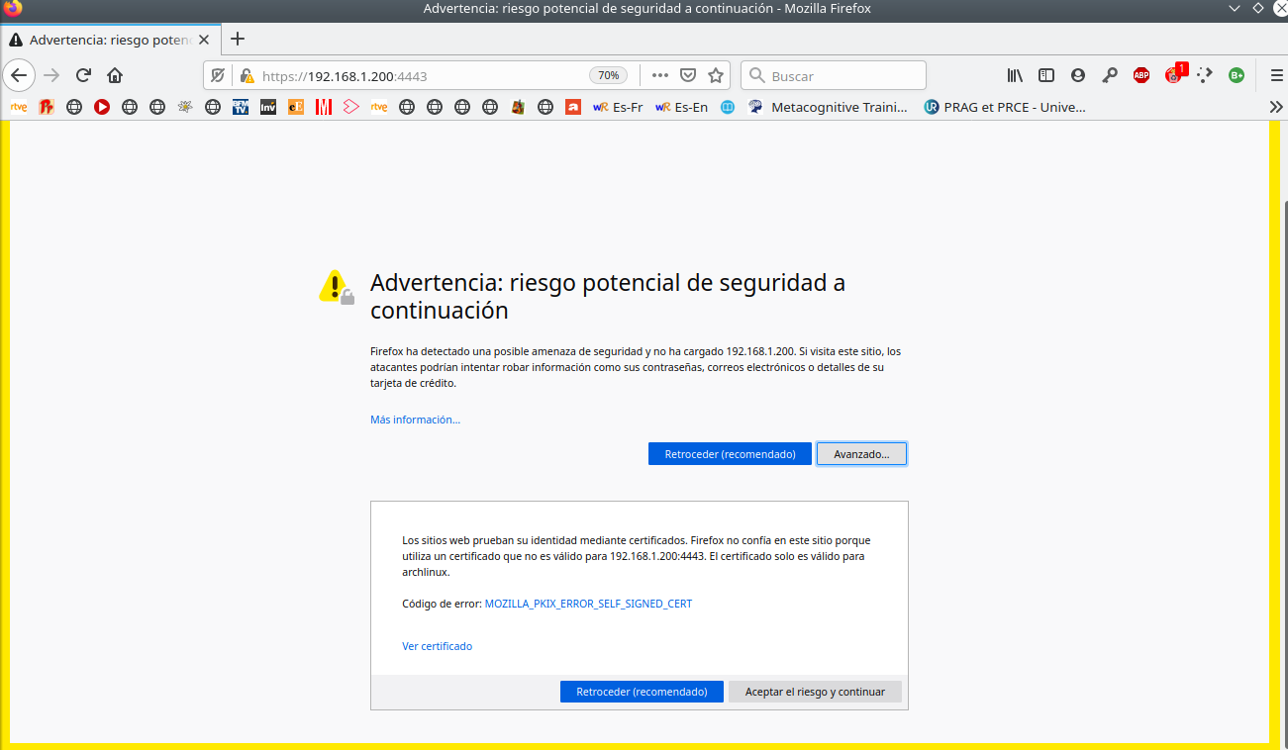
- You have to write your Id and your Password from the NextcloudPi count
  - Id: ncp
  - Password: Ye3FNazH7fBMAXA+7fuOlr9c42zCTHqDhZZxwEesWQc
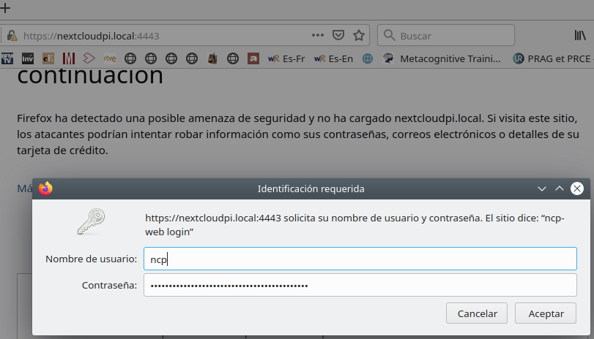
- The fist time, you will see a windows as below.
  - Push “skip”
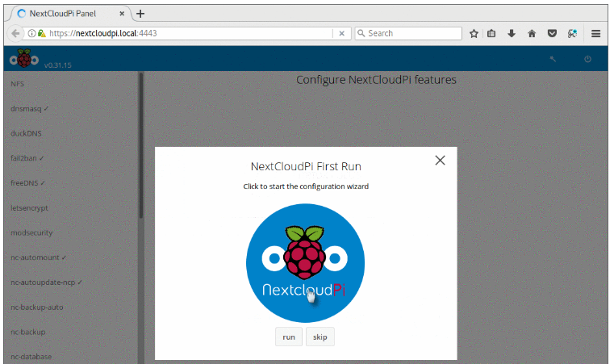
- Change the Nextcloud database location (it’s like a “List of documents”). Without the “List of documents”, Nextcloud will not recognizance your documents stored in the RAID, even if they are stored in the RAID.
  - Go to “CONFIG” → “Nc-database”
    - “Database directory”: /RAID/ncp-database

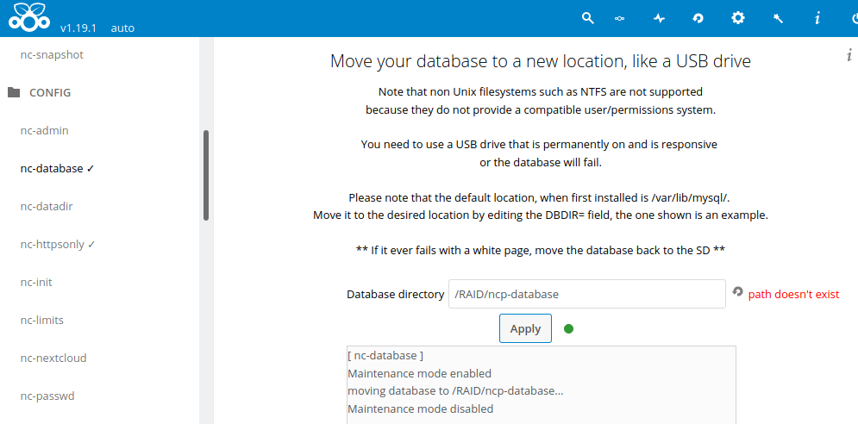
- Change the data folder location of Nextcloud (photos, videos, documents,...)
  - Go to “CONFIG” → “nc-datadir”
    - “Data directory”: /RAID/ncp-data
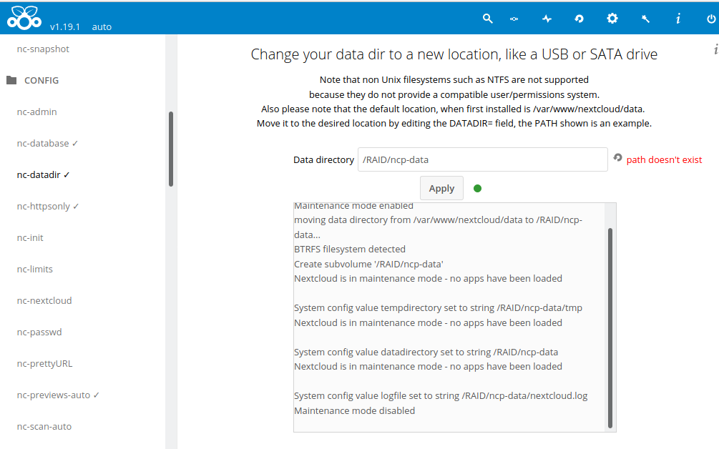
- Change password for admin user ncp for NextcloudPi coutn at localhost:4443
  - Go to “CONFIG” → “nc-passwd”
    - “Password”: 1+1+2+3+5+8+13+21+34
    - “Confirm password”: 1+1+2+3+5+8+13+21+34
    - The symbols are not allowed
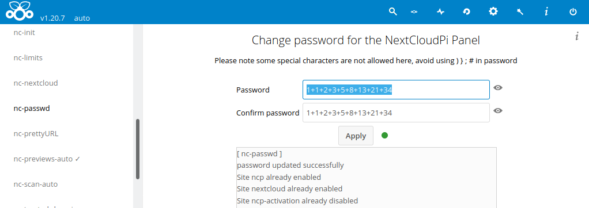

- Change maximum file size
  - Go to “CONFIG” → “nc-limits”
    - “Maximum file size” : 0 (ilimited)
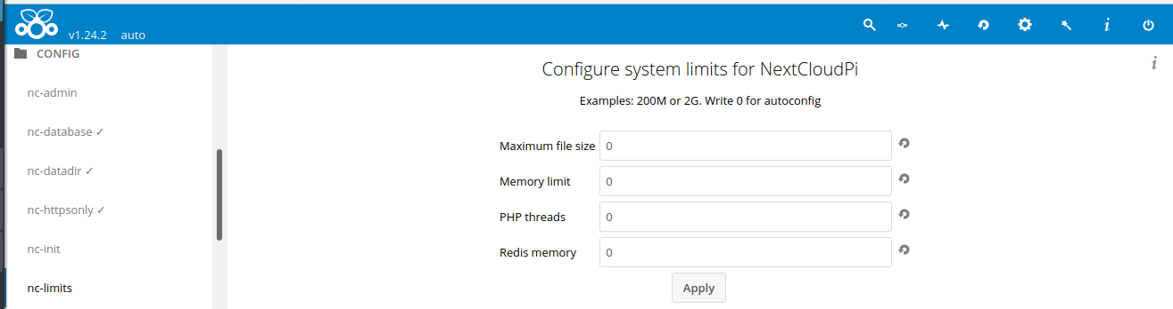
- Periodically scan of new files
  - Go to “CONFIG” → “nc-scan-auto”
    - “Scan periodicity (in minutes)”: 300
    - “Path”: /ncp/files/ncp-backup
    - Push “Apply”
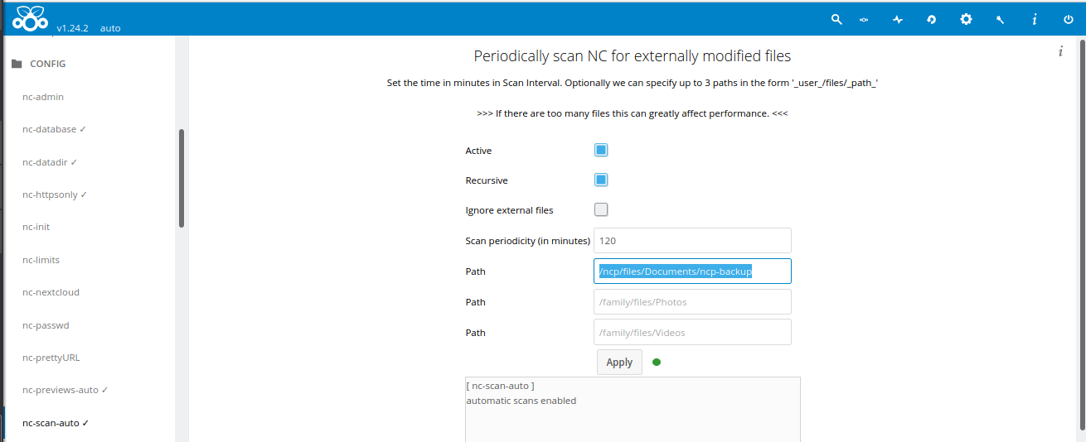
- Security option: Force secure connection using HTTPS
  - Go to “CONFIG” → “nc-httpsonly”
    - Push “Apply”
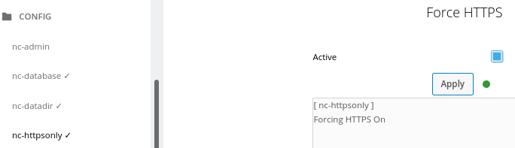
- Periodically generate previews for the gallery
  - Go to “CONFIG” → “nc-previews-auto”
    - “Runtime (in minutes)” : 120
    - Push “Apply”

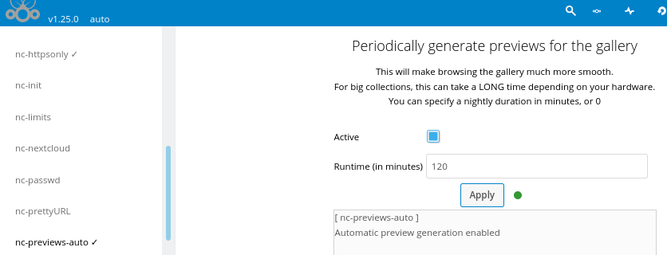

NextcloudPi Configuration - “UPDATES MENU”
- Update all Nextcloud Apps installed
  - Go to “UPDATES” → “nc-update-nc-apps”
    - Push “Apply”
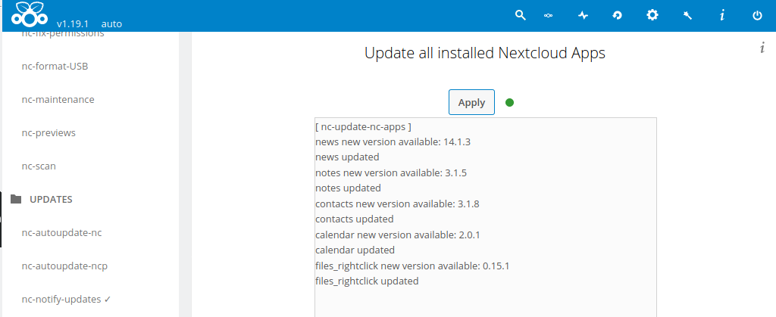
- Update the Nextcloud version
  - Go to “UPDATES” → “nc-update-nextcloud”
    - Push “Apply”
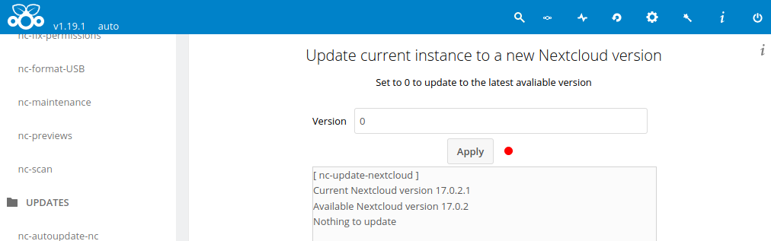

- Perform a manual update of NextClouPi
  - Go to “UPDATES” → “nc-update”
    - Push “Apply”

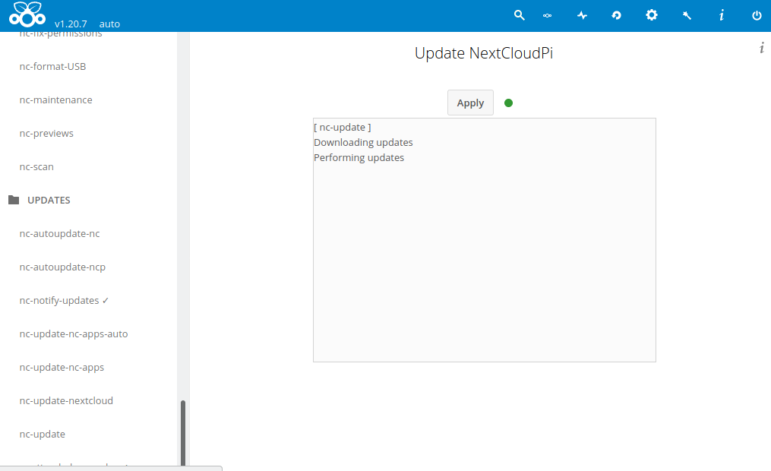
- Automatically Nextcloud update
  - Go to “UPDATE” → “nc-autoupdate-nc”
    - “Active”: Activate
    - “Notify user”: ncp
    - Push “Apply”
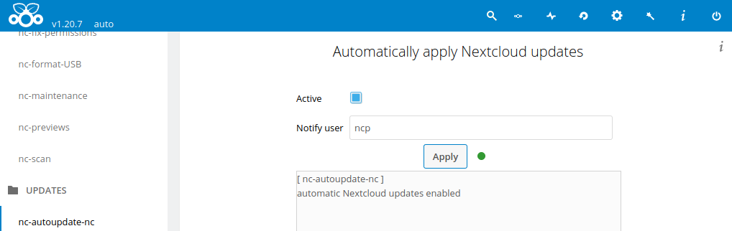
- Automatically update NextCloudPi
  - Go to “UPDATE” → “nc-autoupdate-ncp”
    - “Active”: Activate
    - “Notify user”: ncp
    - Push “Apply”
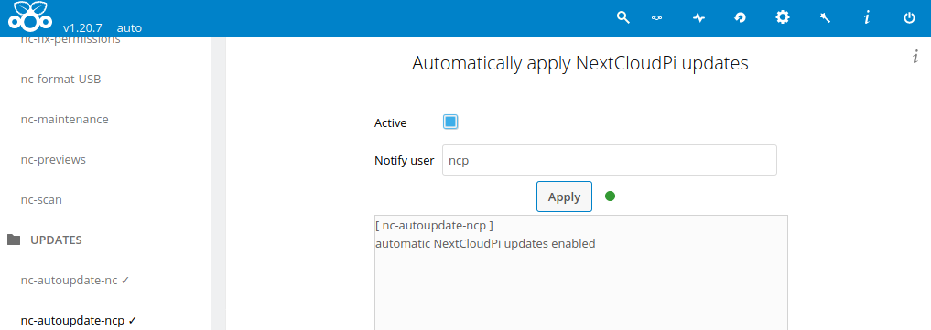
- Periodically update all installed Nextcloud Apps
  - Go to “UPDATE” → “nc-update-nc-apps-auto”
    - “Active”: Activate
    - “Notify user”: ncp
    - Push “Apply”
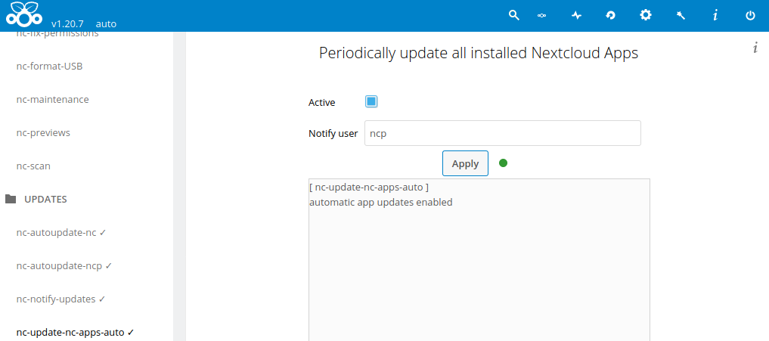
- Enable Automatic installation of security updates to keep your cloud safe
  - Go to “UPDATE” → “unattended-upgrades”
    - “Active”: Activate
    - “Autoreboot”: Activate
    - Push “Apply”
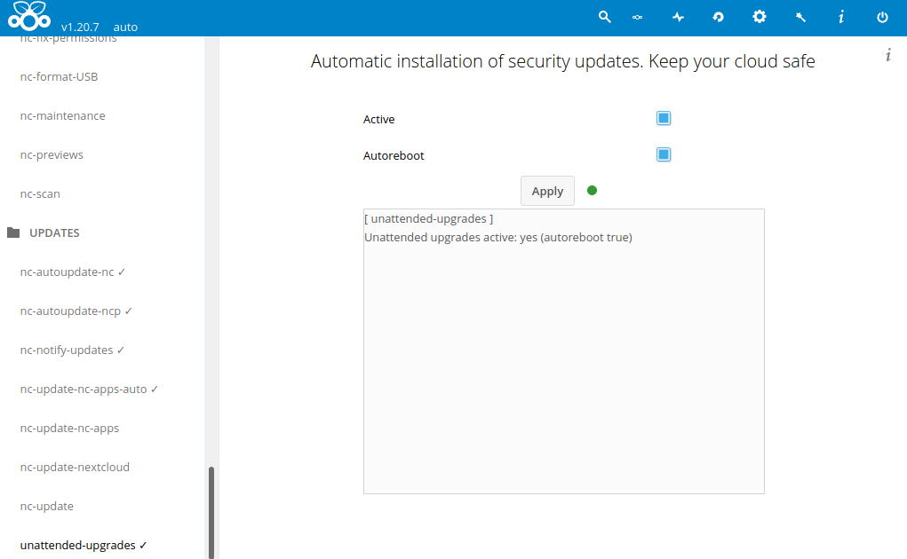

NextcloudPi Configuration - “SECURTY MENU”
- Activate Firewall (security)
  - Go to “SECURTY” → “UFW”
    - “Active”: Activate
    - Push “Apply”
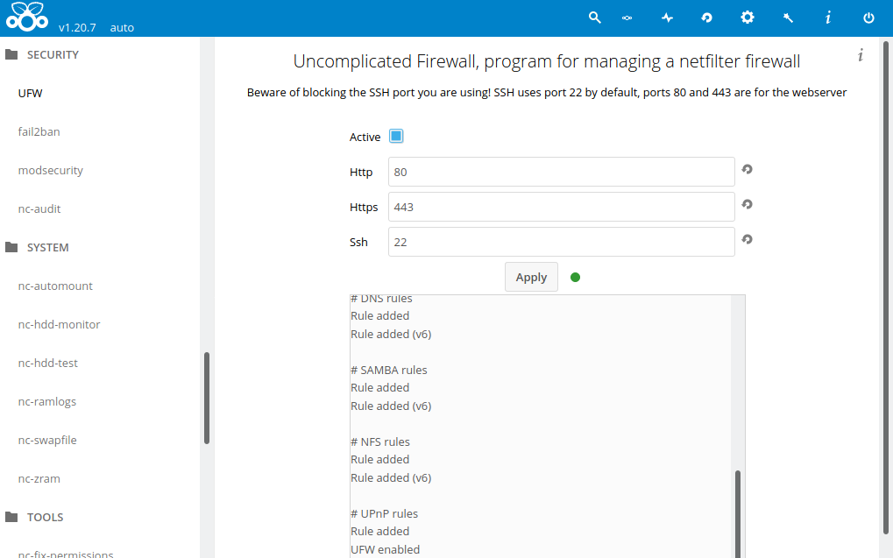
- Brute force protection (security)
  - Go to “SECURTY” → “fail2ban”
    - “Active”: Activate
    - “Bantime”: 600
    - “Findtime”: 600
    - “Maxretry”: 6
    - “Mailalerts”: Activate
    - “Email”: MAIL@gmail.com
      - After 6 wrong password in less than 600, the system is blocked during 600 seconds.
    - Push “Apply”
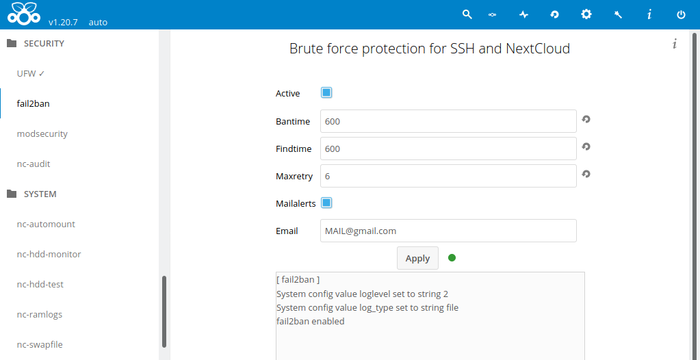

NextcloudPi Configuration - “SYSTEM MENU”
- Mount automatically the USB
  - Go to “SYSTEM” → “nc-automount”
    - “Active”: Activate
    - Push “Apply”
    - It will be mounted in: /media
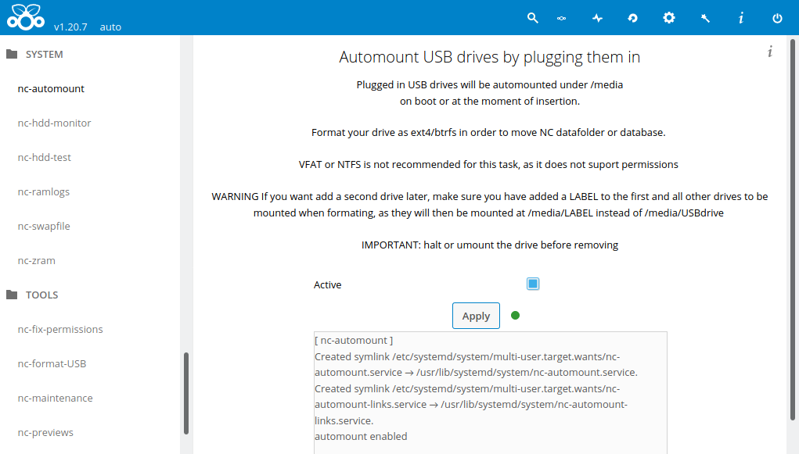
- Monitor HDD health automatically
  - Go to “SYSTEM” → “nc-hdd-monitor”
    - “Active”: Activate
    - “Notify user”: ncp
    - “Email”: MAIL@gmail.com
    - Push “Apply”

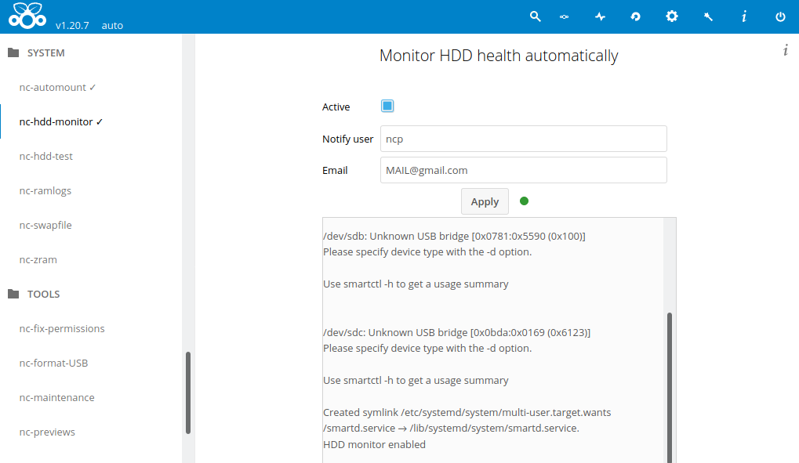
- Change the location and the size of the swap file (as RAM memory)
  - Go to “SYSTEM” → “nc-swapfile”
    - Swapfile: /var/swap
    - Swapsize: 7000
      - 7000, depends of SD memory card capacity
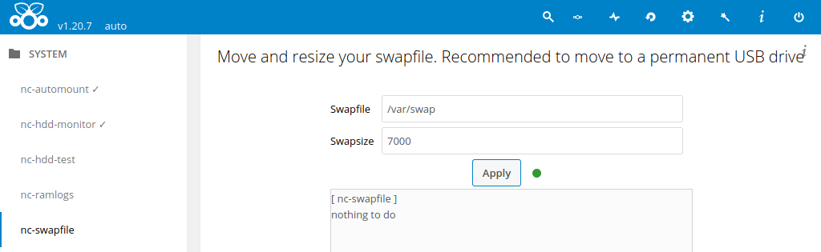

NextcloudPi Configuration - “BACKUPS MENU”
- Perform the first manual backup of (a “List of documents”). Without the “List of documents”, Nextcloud will not recognizance your documents stored in the RAID, even if they are stored in the RAID.
  - Go to “BACKUPS” → “nc-snapshot”
    - “limit”: 30
    - It will be save every hour in /RAID/ncp-snapshots
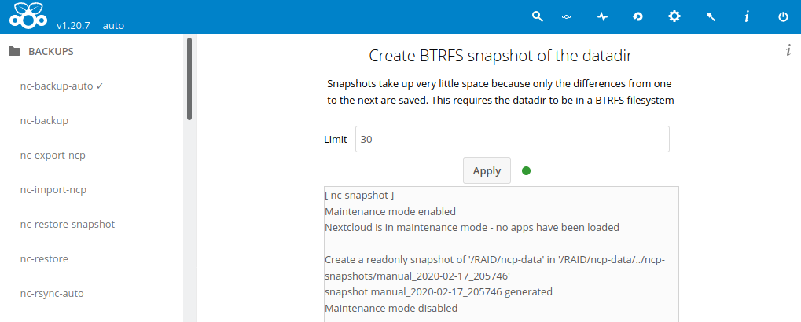
- Perform automatic Backup of database (a “List of documents”…).
  - Go to “BACKUPS” → “nc-snapshot-auto”
    - It will be saved in: /RAID/ncp-snapshots
    - “Active”: Activate
    - Push “Apply”
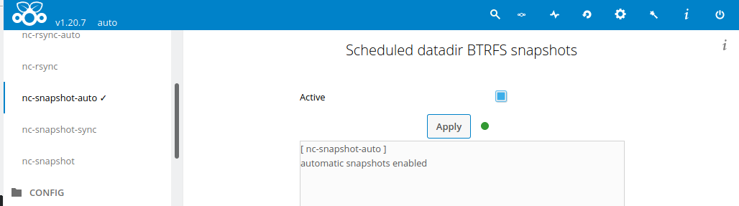

- Perform the first manual backup (Id, password, calendar, contacts, ...)
  - Go to “BACKUPS” → “nc-backup”
    - “Destination directory”: /RAID/ncp-data/ncp/files/ncp-backup
    - “Include data”: Not Activate
    - “Compress”: Activate
    - “Number of backups to keep”: 30
    - Push “Apply”
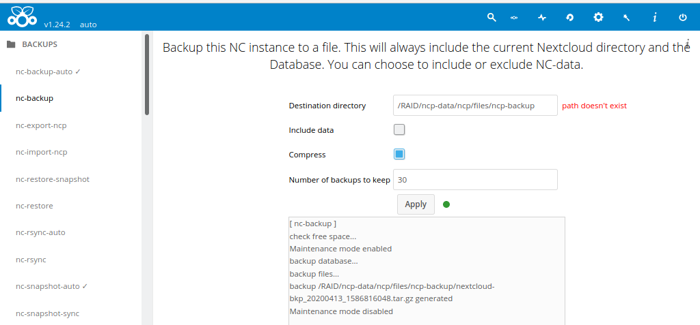
- Perform automatic backups (Id, password, calendar, contacts, ...)
  - Go to “BACKUPS” → “nc-backup-auto”
    - “Active”: Activate
    - “Destination Directory”: /RAID/ncp-data/ncp/files/ncp-backup
    - “Include data”: Unactivate
    - “Compress”: Activate
    - “Backup periodicity (in days)”: 1
        - It will be do 1 backup per day
    - “Backup limit” : 30
        - 30 number of backups saved in all Push “Apply”
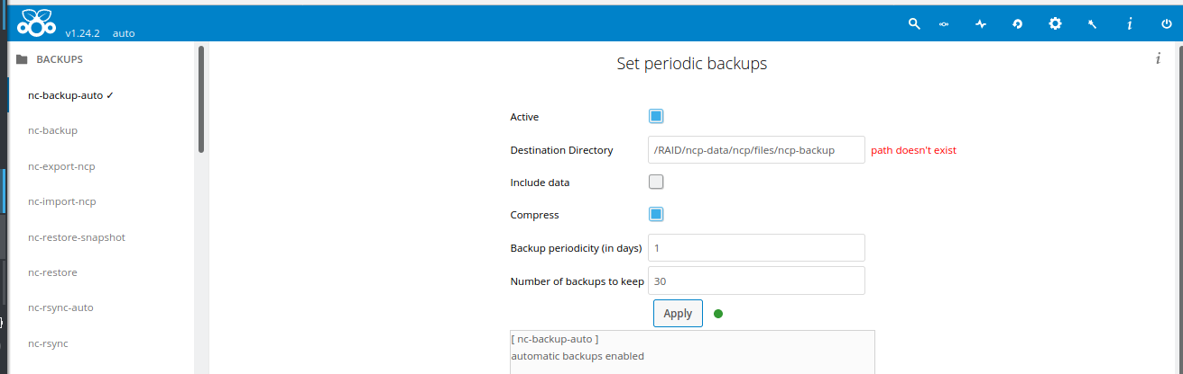

- In order to recognize and sync the backups files into your PC automatically, we need to change the permissions as bellow:
  - Open Putty
  - see the RaspberryPi heure whit : date
  - sudo nano /etc/crontab
  - Write : 45 20 * * * chown -R www-data:www-data /RAID/ncp-data/ncp/files/ncp-backup
    - * : Once a day
    - 20 : At 20h
    - 45 : and 45 min
    - Following the structure : MM HH DD mes ww USER PROGRAMA
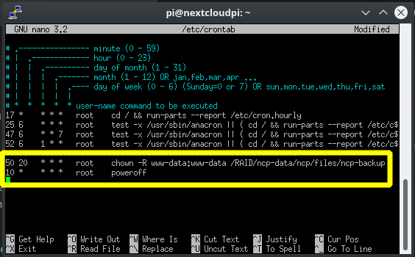
  - Exit phusing:
    - Crtl + X
  - Save the changes pushing Y and Enter
- Change the time of automatic backups (at 3 am by default), as explained before:
  - sudo nano /etc/cron.d/ncp-backup-auto
  - Write : "00 21 * * * root /usr/local/bin/ncp-backup-auto”
    - * : Once a day
    - 21 : At 21h
    - 00 : and 0 min
    - You can now the hour of your Pi with : date
    - Following the structure : MM HH DD mes ww USER PROGRAMA

- You can change the time of automatic poweroff, as explained before:
  - sudo nano /etc/crontab
  - Write : "0 21 * * * root poweroff”
    - * : Once a day
    - 21 : At 21h
    - 00 : and 0 min
    - You can now the hour of your Pi with : date
    - Following the structure : MM HH DD mes ww USER PROGRAMA

- Export NextCloudPi configuration (ncp-backup-auto, nc-database, nc-datadir, ...)
  - Go to “BACKUPS” → “nc-export-ncp”
    - “Directory”: /RAID/ncp-data/ncp/files/ncp-backup
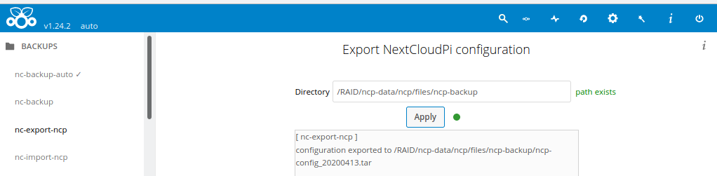

External access
Very probably your public IP change from time to time. In order for you to be able to access your Nextcloud, from outside of your house, you need a DDNS service tracks IP. There are different options, for exemple duckDNS, freeDNS, no-ip or spDYN. I have tried duckDNS, it’s totally free, it works but I didn’t know to solve a problem with my Nextcloud app. Finally, I have chosen OVH. It’s 3€/year and I have not problem.
- Buy domain name
  - Go to OVH website (from your country) → Hosting → Domain → Continue
  - Chose a free name and an extension for you domain (the .ovh extension is cheaper): for exemple mypersonaldomain.ovh
  - Select DNSSEC service and Standard Service → Continue
  - Select I don’t need a web hosting package with my domain name → Continue
  - Finally , you open a compte and pay the domain
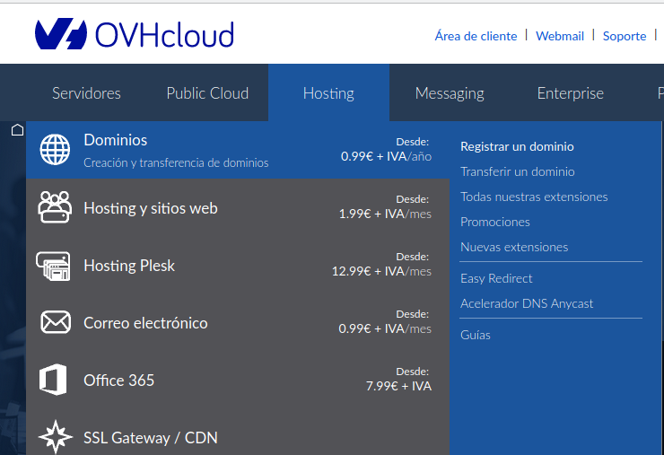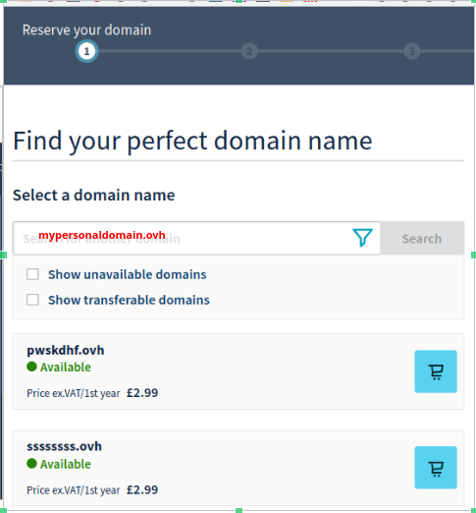
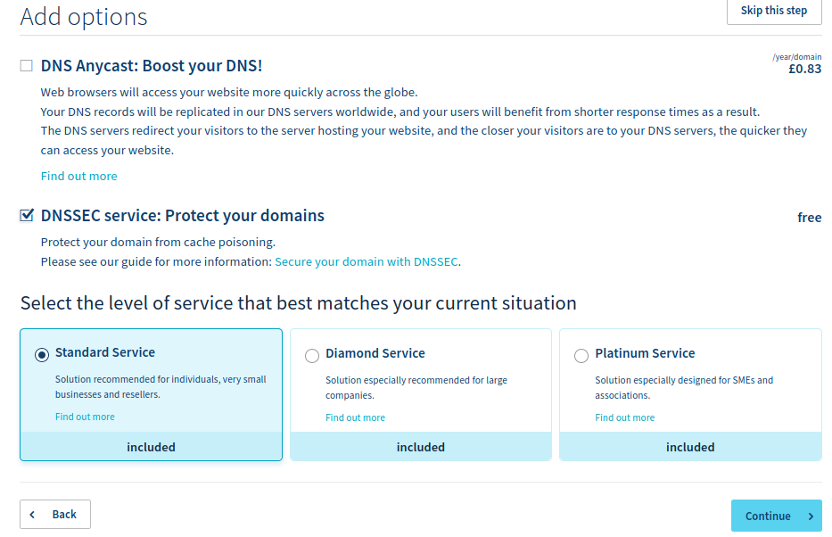
- Configuration OVH count
  - Open your count → Domains → mypersonaldomain.ovh
  - In General information → Security, you can enable the two options
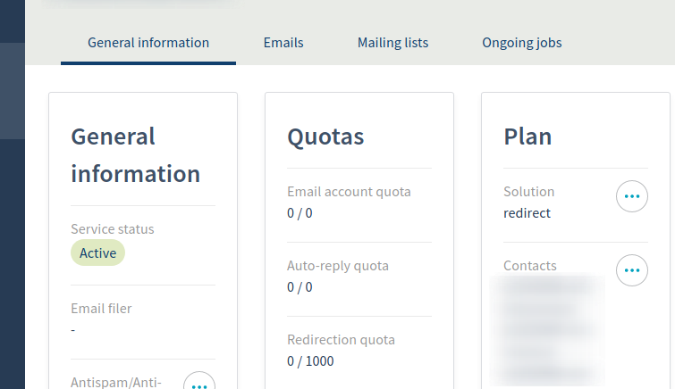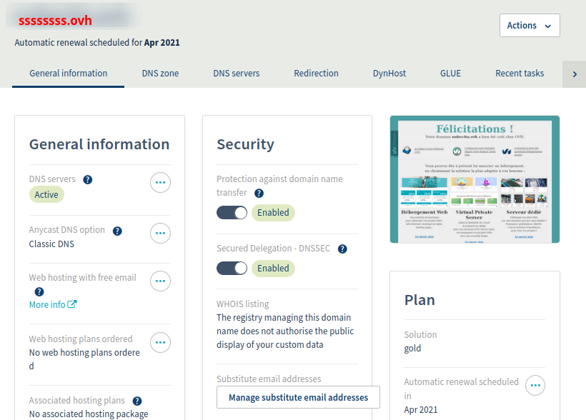
  - Go to DynHost → Manage access → Create a username
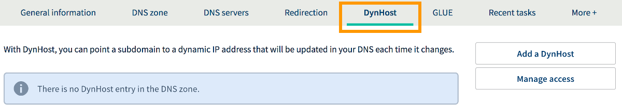
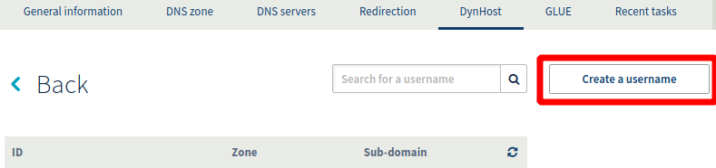
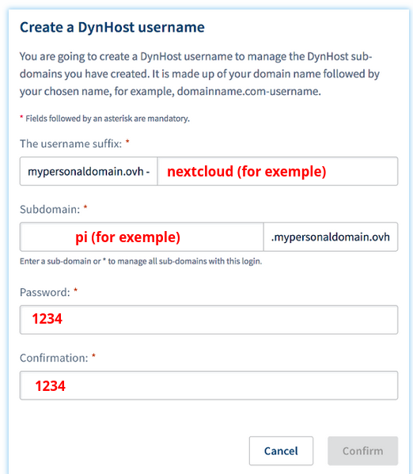
  - Now we will need to know the public IP
    - Open Putty
    - Write : curl ifconfig.me
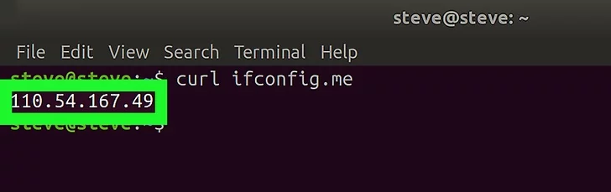
  - Back to DynHost → Add a DynHost
    - Subdomain : Pi
    - Public IP : 110.54.167.49
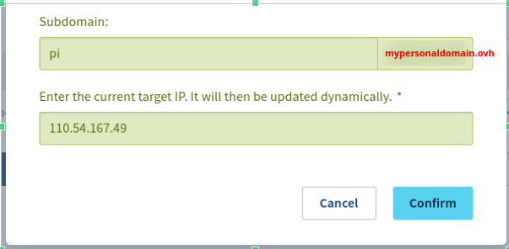
  - Came back to https://nextcloudpi.local:4443 → Config → nc-trusted-domains
    - “Trusted Domain #1”: pi.mypersonaldomain.ovh
    - “Trusted Domain #2”: 110.54.167.49
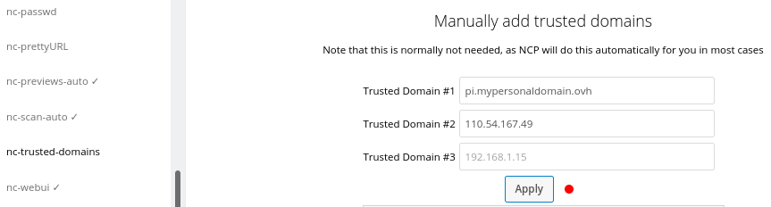

- Configuration of router (Free box for exemple)
  - Now we will need to know the router IP
    - Open the application Fing in you smartphone
    - Then, connect your smartphone by wifi and looking for the devices connected
    - You will recognize your IP address of your router (in my case 192.168.1.35 see the orange square)
  - Write the router IP in to your navigator → Parametres → DNS Dynamique → Configuration → OVH :
    - “Utilisateur” : mypersonaldomain.ovh-nextcloud
    - “Mot de passe” : 1234 (ATTENTION! It’s the password from DynHost Username for OVH)
    - “Nom d’hote” : pi.mypersonaldomain.ovh
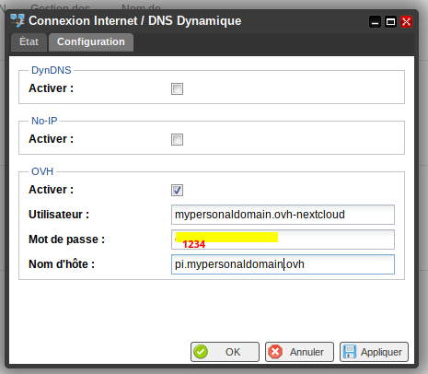
  - Last step, came back again to your router. Write the router IP in to your navigator → Parametres → Gestion des ports → Redirections de ports → Ajouter :
    - “IP Destination” : 192.168.1.200 (ATTENTION! It’s the IP of RaspberryPi, see pag 6)
    - “Redirection active” : Active
    - “IP source” : Touts
    - “Protocol” : TCP
    - “Port de début” : 443
    - “Port de fin” : 443
    - “Port de destination” : 443
    - “Commentaire” : Cloud (for exemple)

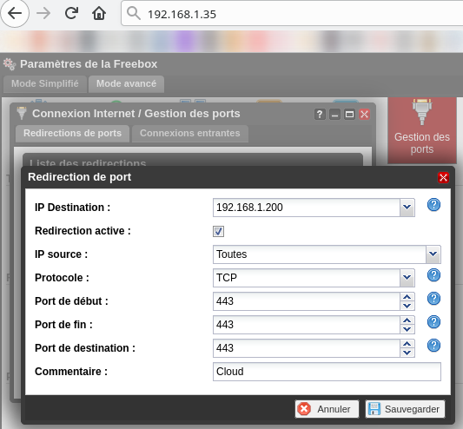

Install Nextcloud-client
- For Linux:
  - sudo add-apt-repository ppa:nextcloud-devs/client
  - sudo apt update
  - sudo apt install nextcloud-client
- For Windows or Mac, you can install Nextcloud Desktop from :
https://nextcloud.com/install/#install-clients
- Open the Nextcloud client → Enter :
  - “Server direction” : pi.mypersonaldomain.ovh
  - Click to Follow
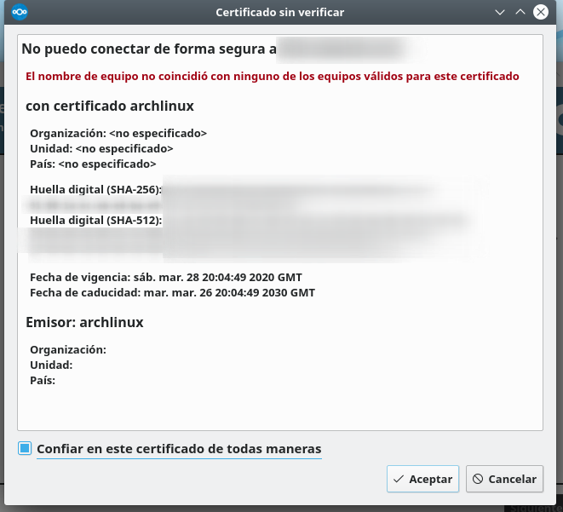
  - And accept the certificate
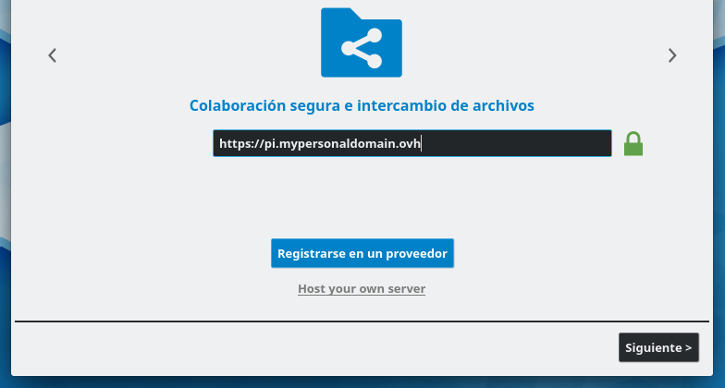
  - The next windows will open the web navigator.
  - Open your Nextcloud count and give the authorizations
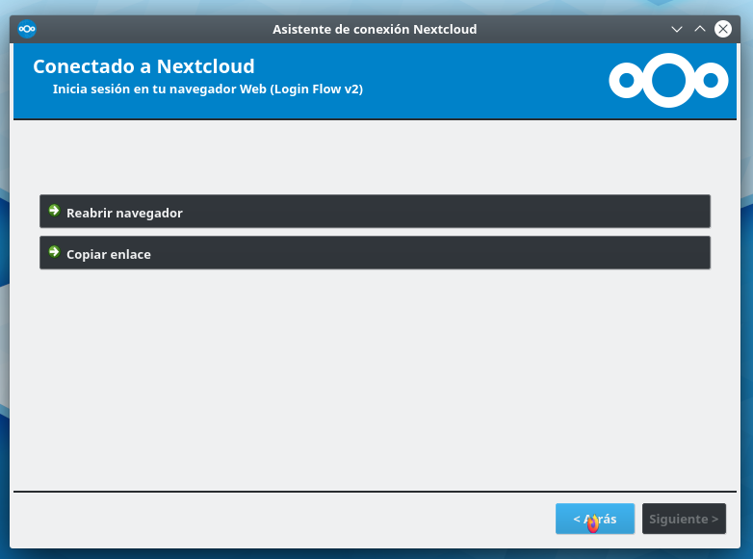
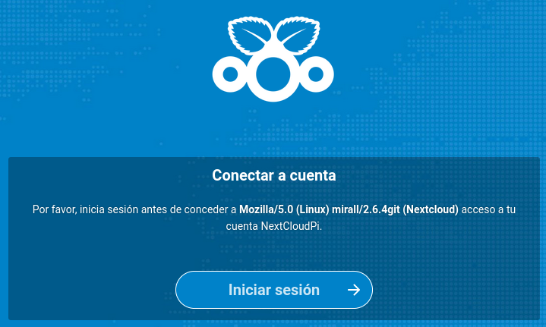
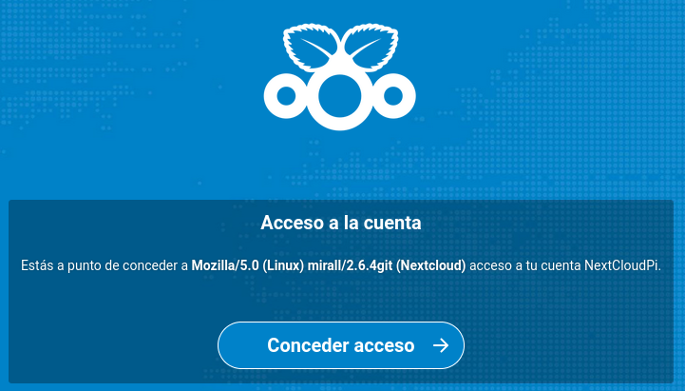


- In my case, I sync my folders one by one
  - For exemple the ncp-backup folder from the RaspberryPi with my ncp-backup folder form my PC
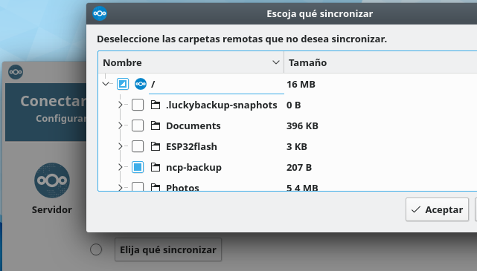
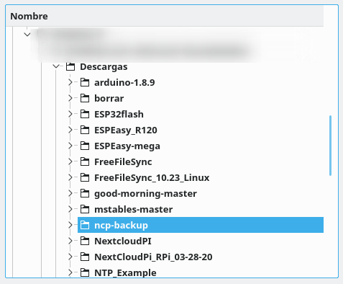
- Finally, the 2 folders will be sync each other :
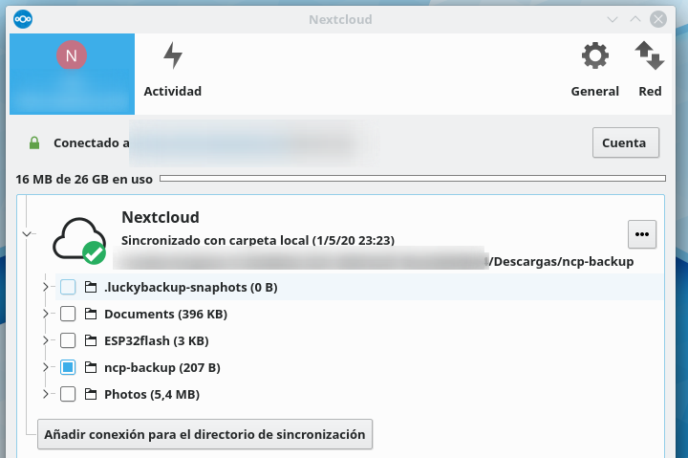

THE END

